Getting Started
Everysk App Template on Replit

Prerequisites
Before importing the template, gather the following credentials from your Everysk account at https://everysk.com/account

- EVERYSK_API_SID — Your Everysk API account SID
- EVERYSK_API_TOKEN — Your Everysk API authentication token
- EVERYSK_APP_NAME — The name for your Everysk application

Importing the Template into Replit

Step 1 — Open the GitHub Template
Navigate to the template repository on GitHub:
https://github.com/Everysk/replit-templates

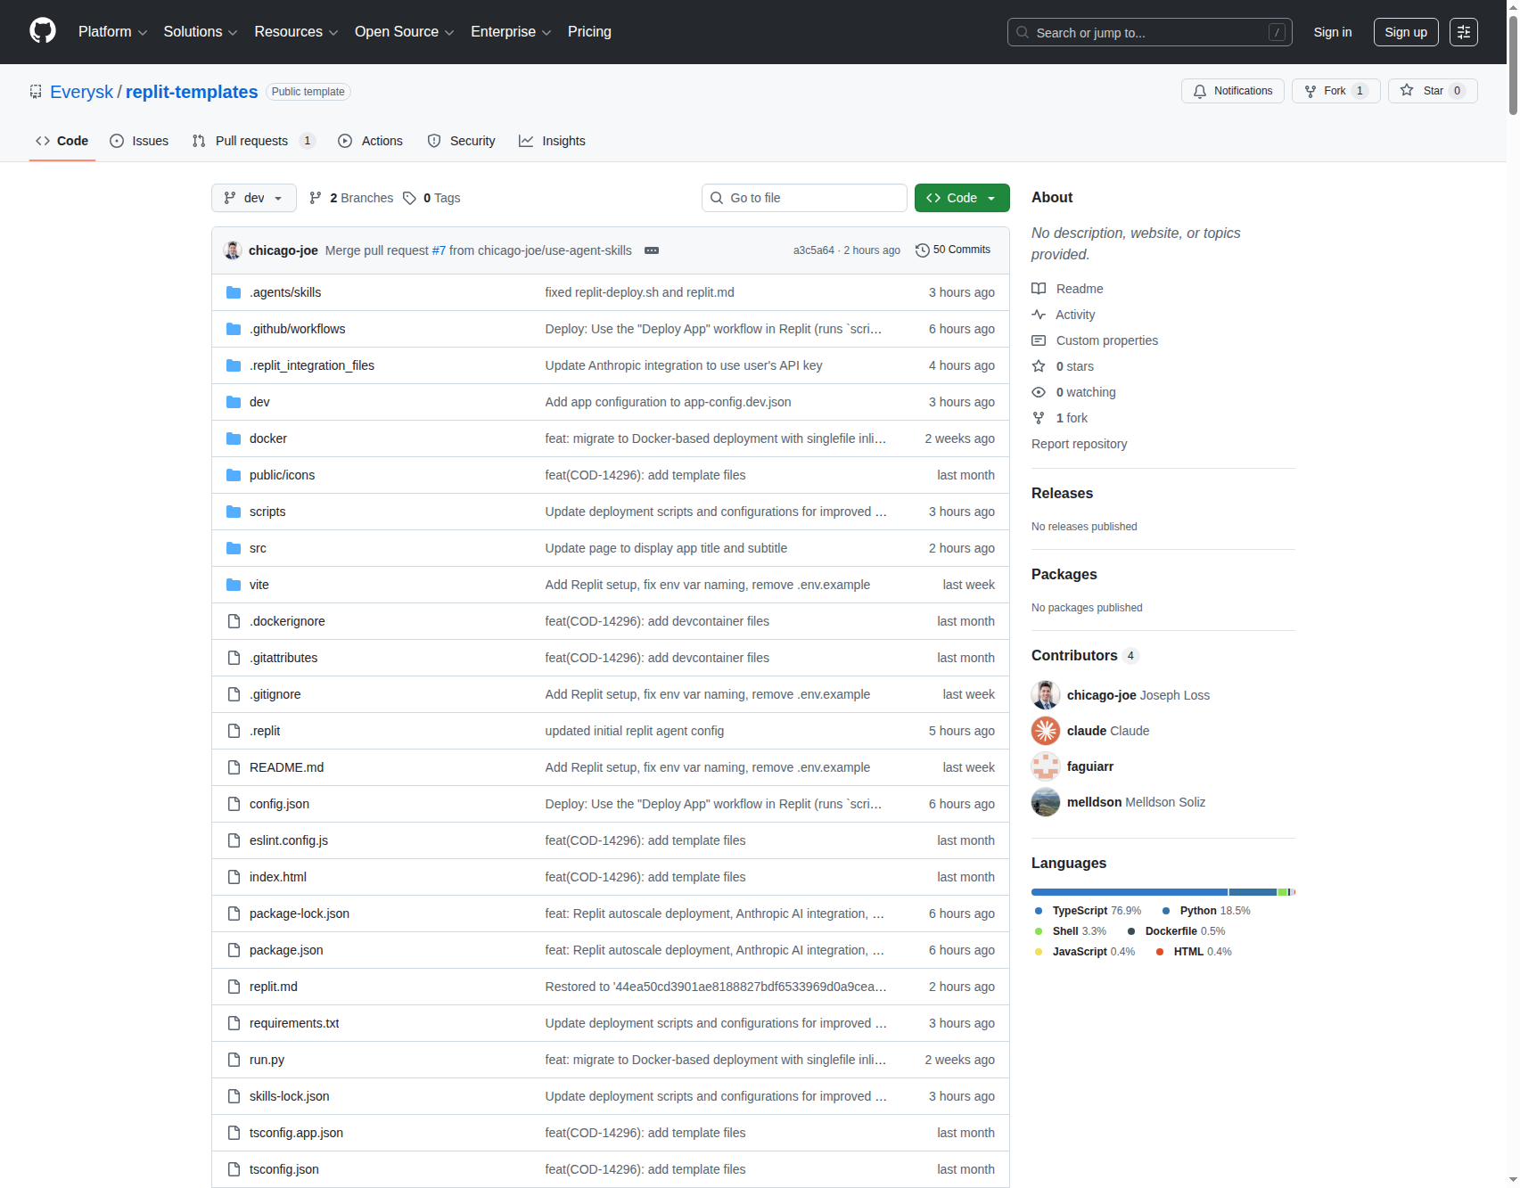
Figure 1: Everysk template repository on GitHub

Step 2 — Import into Replit
Open the following URL to import the template directly into Replit:
https://replit.com/github/Everysk/replit-templates
Sign in to Replit if prompted, then click Fork or Import to create your own copy.

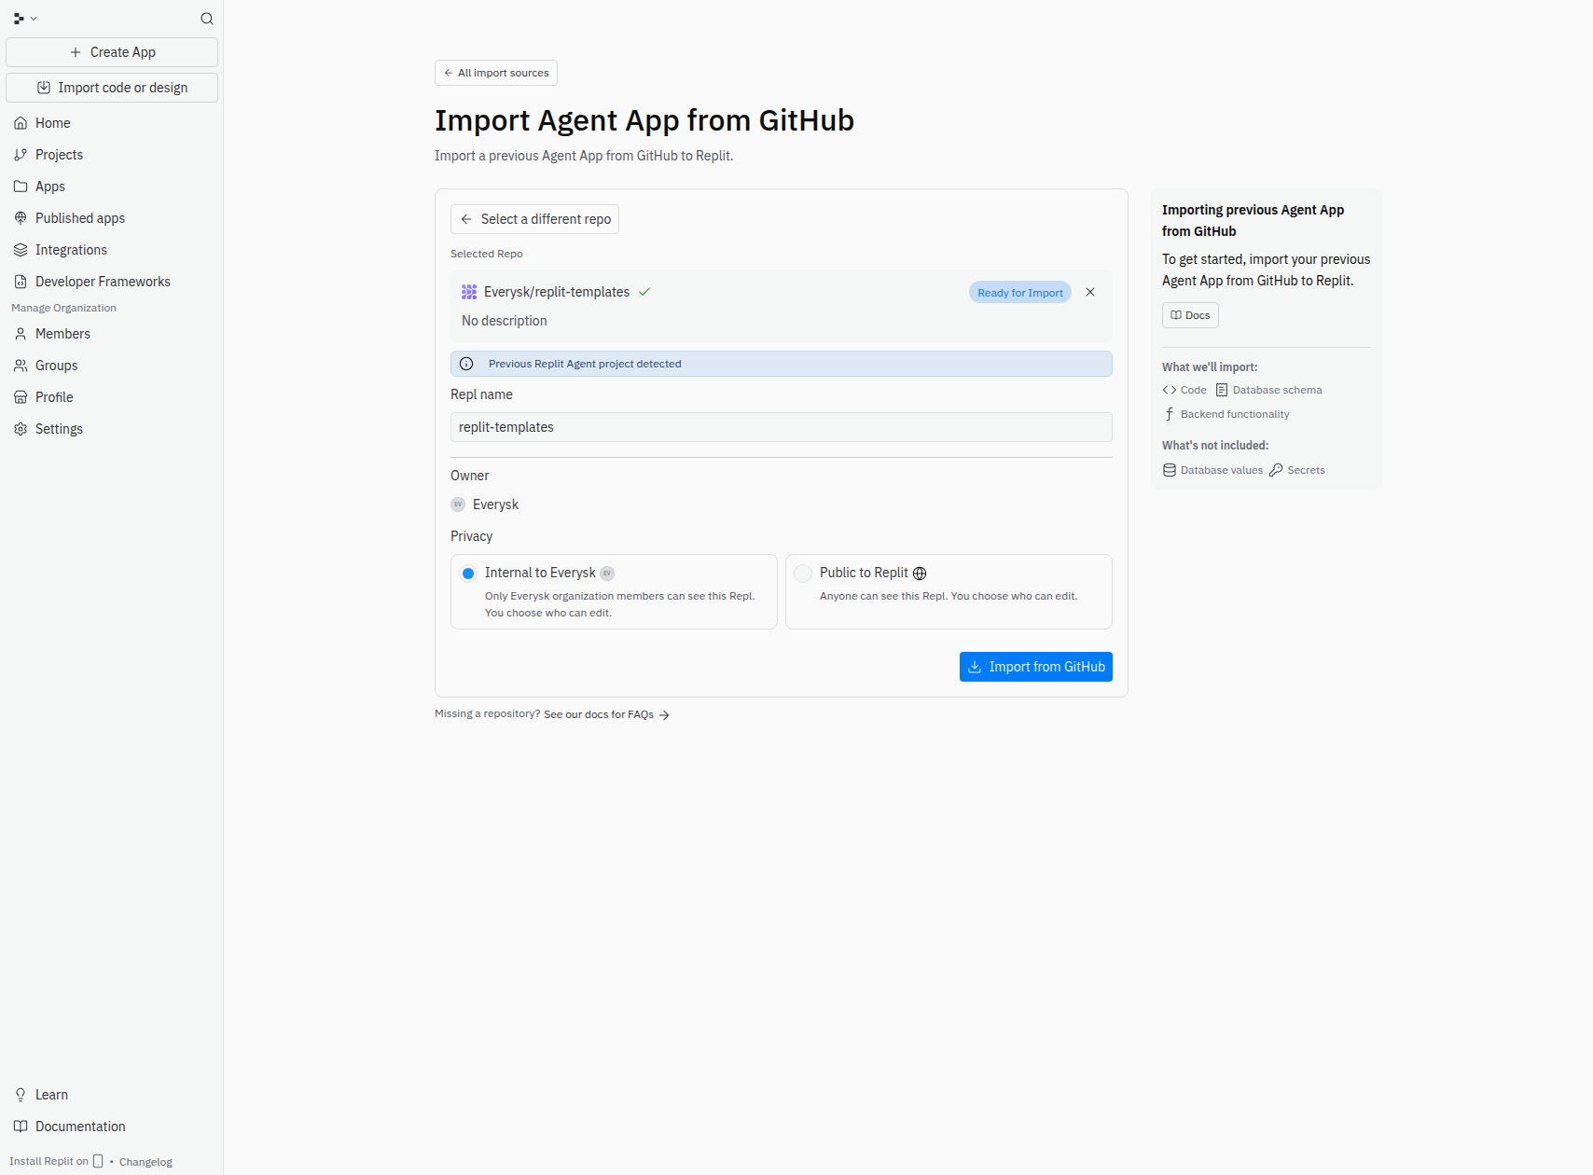
Figure 2: Replit import / fork page

Step 3 — Your Replit Workspace
After the import completes, Replit opens your new workspace with the project files in the left panel and the shell at the bottom.

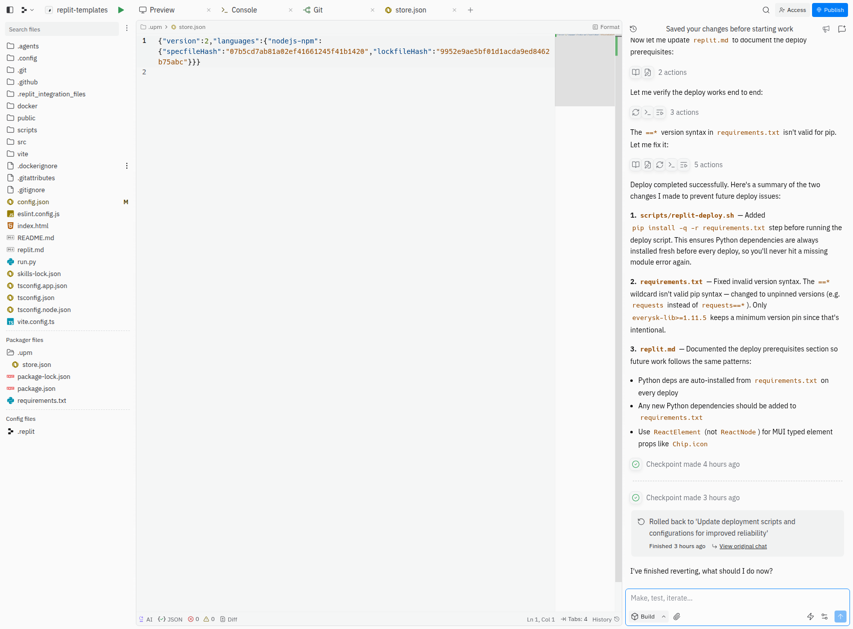
Figure 3: Replit workspace after import

Step 4 — Open the Secrets Tab
Click the lock icon (🔒) in the left sidebar to open the Secrets tab. This is where you store environment variables securely — they are never committed to your repository.

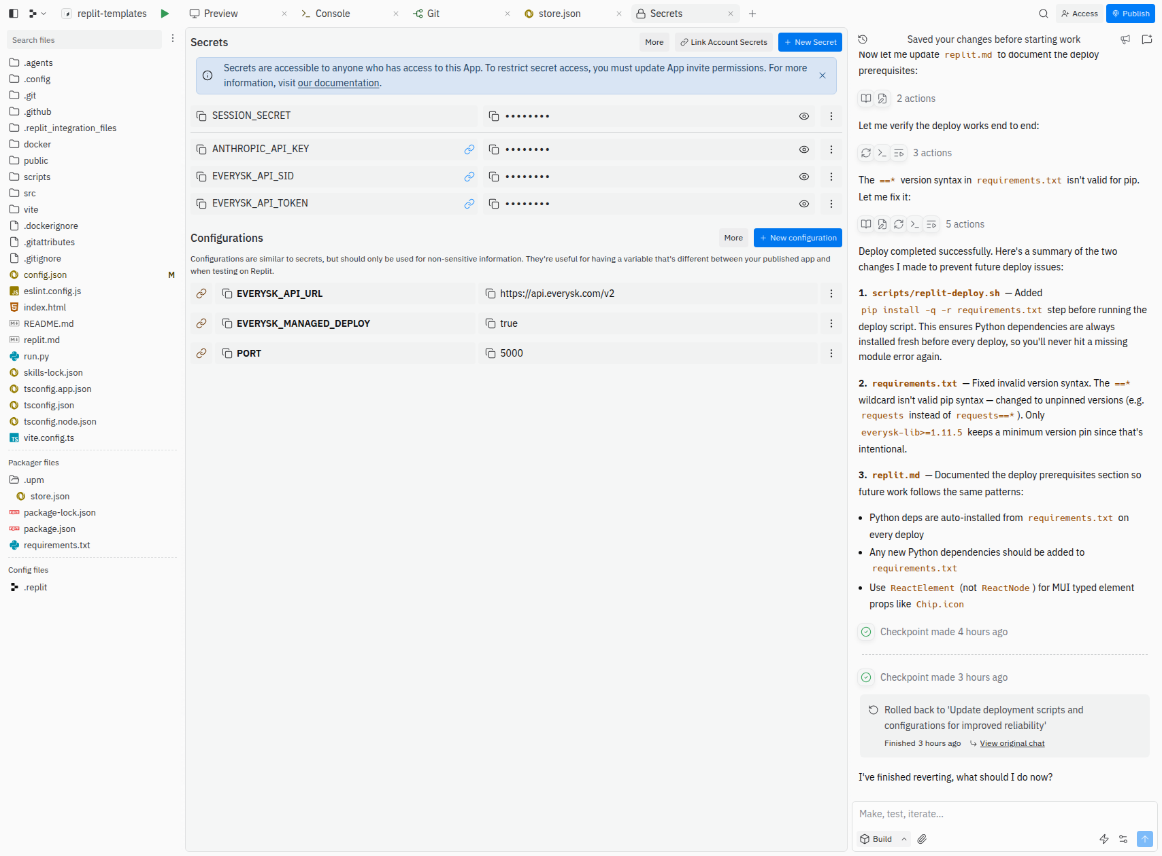
Figure 4: Secrets tab (lock icon in sidebar)

Step 5 — Add Required Secrets
Add each of the following secrets by clicking New Secret, entering the key name, and pasting the value:

- Key: EVERYSK_API_SID → Value: your API SID from everysk.com/account
- Key: EVERYSK_API_TOKEN → Value: your API token
- Key: EVERYSK_APP_NAME → Value: your application name

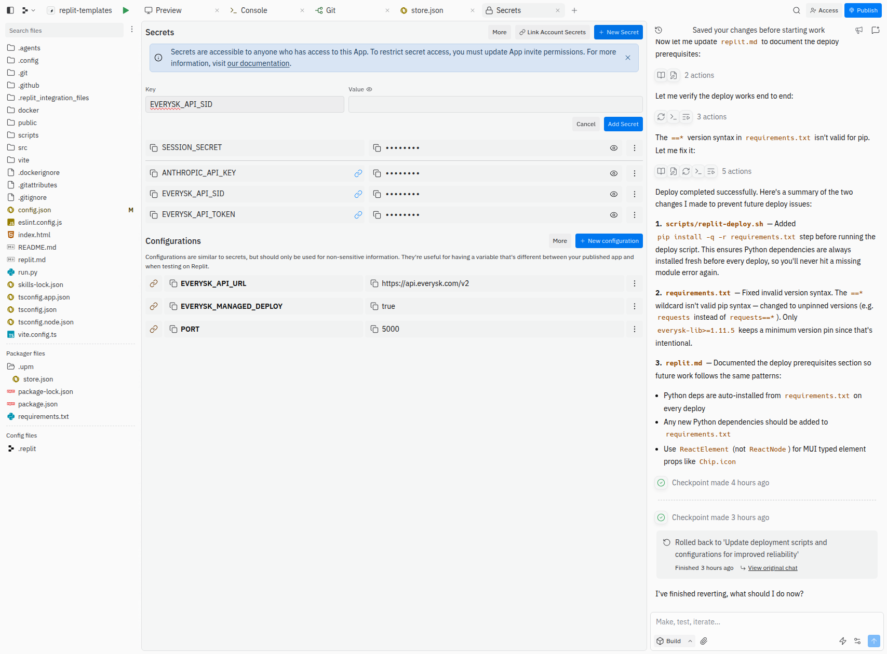
Figure 5: Adding the EVERYSK_API_SID secret

Step 6 — Run the App
Click the green Run button at the top of the workspace. The startup script validates all required secrets before starting the Vite dev server on port 5000. If any secrets are missing, you will see a clear error in the console.

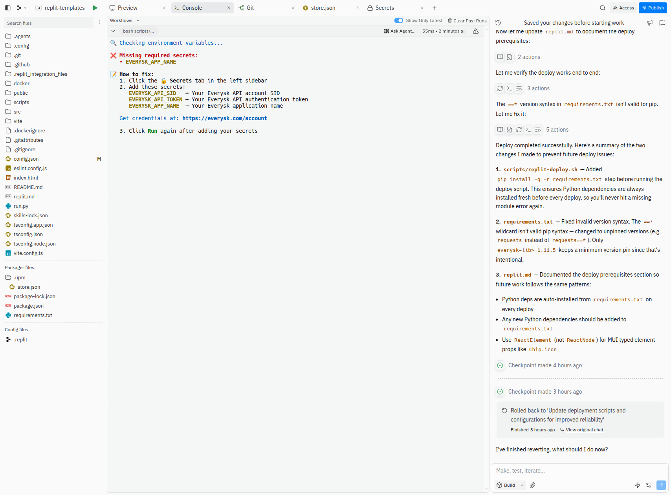
Figure 6: App running in Replit

Understanding Agent Skills
This template ships with AI agent skills in the .agents/skills/ directory. These are instruction files that tell the Replit AI agent (and Claude Code) how to approach specific tasks correctly.

Skills are automatically discovered by any agent that reads replit.md, which lists all mandatory skills with their paths and “When to Use” criteria.

Available Skills

Skill | Path | When to Use
brainstorming | .agents/skills/brainstorming | Before any creative/feature work — design first, code second
everysk-lib-sdk | .agents/skills/everysk/everysk-lib-sdk | Everysk Python SDK: portfolios, datastores, workflows
everysk-mcp | .agents/skills/everysk/everysk-mcp | Everysk MCP server integration patterns
everysk-worker-builder | .agents/skills/everysk/workers-everysk-skill | Building new workers in the Everysk workers-everysk platform
frontend-design | .agents/skills/frontend-design | Building or styling any UI — MUI + Tailwind best practices
agent-tools | .agents/skills/agent-tools | AI model inference, image/video generation, web search via CLI
pdf | .agents/skills/pdf | All PDF operations: read, write, merge, OCR, forms
find-skills | .agents/skills/find-skills | Discover installable skills for new capabilities

How to Invoke Skills

In Claude Code (terminal):
Skill(skill="brainstorming")
Skill(skill="everysk-lib-sdk")
Skill(skill="frontend-design")

In Replit AI Agent:
Skills are loaded automatically. The agent reads replit.md at the start of every conversation and loads the relevant skill before performing matching work.

Key Skill: brainstorming
The brainstorming skill enforces design-before-code discipline. Every time you ask the AI agent to build a new feature, it will:
- Explore the codebase and understand the current context
- Ask clarifying questions one at a time
- Propose 2–3 approaches with trade-offs
- Present a design for your approval before writing any code

This prevents wasted work and ensures alignment before implementation begins.

Troubleshooting

Missing secrets error on startup
If you see a secrets validation error in the console, open the Secrets tab and verify all three secrets are present: EVERYSK_API_SID, EVERYSK_API_TOKEN, and EVERYSK_APP_NAME. Then click Run again.

Agent not loading skills
If the Replit agent skips the brainstorming or everysk skill steps, ask it to re-read replit.md. The file contains the mandatory skill requirements that must be followed in every conversation.

App not loading in Replit webview
- Verify the dev server started on port 5000 (check console output)
- Check that all three secrets are set correctly
- Try stopping and re-clicking Run
- Open the Replit shell and run: bash scripts/check-env.sh

